Project Report

Group22:

Table of Contents

1. INTRODUCTION
1.1. PURPOSE
1.2. PROJECT BACKGROUND
2. PROJECT PLAN
2.1. PROJECT OBJECTIVES
2.2. CONSTRAINTS & BOUNDARIES
2.3. PROJECT ORGANIZATION
2.4. PROJECT STAKEHOLDERS
2.5. WBS
2.6. GANTT CHART
2.8. SCHEDULE
2.9. SOFTWARE DEVELOPMENT METHODOLOGY
2.10. SOFTWARE CONFIGURATION
2.11. USE OF TECHNOLOGIES AND PLATFORMS
3. ANALYSIS
3.1. DESIGN CONSTRAINTS
3.2. CLASS DIAGRAM
3.3. SEQUENCE DIAGRAM
3.4. DESIGN PATTERN
4. TEST PLAN
4.1. TESTING MODULE HIERARCHY
4.2. TEST PLAN DESCRIPTION
4.3. UNIT TEST
4.4. INTEGRATION TEST
4.5. SYSTEM TEST
5. BUG REPORT

1. INTRODUCTION

1.1 PURPOSE

The purpose of the project report is to describe the approach for managing the implementation for the Timetable Packer application.

It provides an overview of the project’s background, objectives, project plan, analysis and test and bug report for the project. It identifies the management structure and highlights activities, processes and/or procedures in the management of the project.

1.2 PROJECT BACKGROUND

Time management is crucial for college students, who need to balance their students with personal lives. With effective time management, it is possible for college students to level themselves up from medicore to superior performance. Realizing the importance of effective time planning and scheduling, we (GeekHub) come up with an initiation to help students create a flexible timetable of their own. With a desirable timetable, it is largely believed that students may likely achieve their goals and manage their time effectively with better control of time.

In light of the fact that course registration in CityU AIMS may sometimes create uncertainties and unknowns, it is essential for students to have plans for their course choices in the semesters in accordance with their own schedule. Because of the fact that some courses can be competitive among students or other factors, students may experience time when they fail to register their preferred courses ,and therefore, they may need to make sudden amendments to their study plan, which may lead to a chaos in their semester timetable. Owning to the above unanticipated factors during course registration, we think that strategies can be prepared if there is an application that can automatically react to users’ course information input and thereby generate an acceptable semester timetable. In that sense, students can prepare themselves with their course preference. When any changes in their course plan, they can quickly respond to it with a backup plan, without ruining their semester study plan. With such a program, it is believed that students can quickly generate different combinations of timetables with reference to their preference courses and available time and benefit greatly to their academic studies.

2. PROJECT PLAN

2.1 PROJECT OBJECTIVES

The main objectives of the project are to:

(a) Generate desirable timetables for students to register courses;

A timetable does matters to students because it help to manage academic studies. It is hoped that Timetable packer can aid students to create an ideal timetable to achieve better life balance and reduce the amount of time spent in timetable planning.

(b) Allow input in .txt file taken directly from Master class schedule in CITYU AIMS;

To enable users’ natural response, quick and simple producible input steps are required to take all course information needed to produce desirable timetable as output. The program should allow input text file, where users copy all the course information directly from Master class and paste into.

(c) Create timetable by inputting criteria, i.e. day off and time differences between lessons, as well as users’ ranking / priority to the time preference; and

The program should be able to process and analysis the time-related criteria such as free time block. By further asking for users’ prioritizing of those criteria, the program should be able to create a timetable solely based on users’ time-specified criteria and ranking.

(d) Process the input information and allow internal elimination of any undesirable factors e.g. crashed timeslots.

Input course information may contain sessions which contains undesirable factors (i.e. unwanted timeslots) or/ and crashed timing. The program should eliminate those duplicated/crashed timeslots before creating the timetable.

2.2 CONSTRAINTS & BOUNDARIES

The main constraints and boundaries of the project are as follow:

- User Interface will be limited due to java application environment;

- An input file with specific format and course information needed to be prepared for program to identify and verify

Owning to technical insufficiency, we cannot get access to the AIMS database to preload all course information. Therefore, a manual input method is required by the users in order obtain program required information. Besides, the input format is restricted to a pre-set format for easy program recognition.

- Assumption of most courses comprised of Lecture and Tutorial only is made;

To keep the project scope manageable, the java program only serve for lecture and tutorial while excluding other options such as lab sessions and seminars. For simplicity, it is assumed that only lecture and tutorial sessions present for all courses in this project.

- Preference of timetable is limited to time-specific ones; and
Due to technical difficulties, users can only rank the predefined preference option. Those preference options are also noted to be time-related ones, i.e. 30 minus break.

- Ranking system is pre-determined and number of preference options of timetable is limited.
To keep the program size small, there are only 4 preference options available for the timetable program. Users can only rank their priority of these 4 options to generate timetable.

2.3 PROJECT ORGANIZATION

This project is a joint effort of members in the project team. This section provides further details on different roles for individuals in the team.

2.3.1 Organization Structure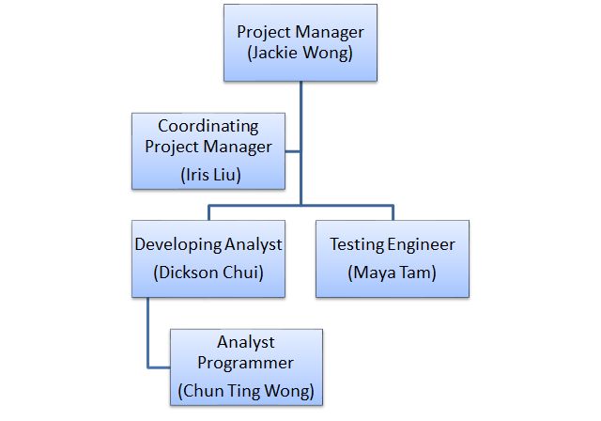

2.3.2 Members of Project Organization

Role | Name / Title | Bureau / Department /
Role | Name / Title | Company
Project Managers
Project Manager | Jackie / PM | GeekHub
Coordinating Project Manager | Iris / CM | GeekHub
Project Team
Developing Analyst | Dickson / Developing Analyst | GeekHub
Testing Engineer | Maya / Testing Engineer | GeekHub
Analyst Programmer | Suki / Analyst Programmer | GeekHub

2.4. PROJECT STAKEHOLDERS
Stakeholders:
Stakeholders | Description
Users | Users of this system are basically student or professors. They can input information to get desirable timetable.
Developers | Developers are the team members which are responsible for developing this program.
Computer | Computer plays a role of processing the program, calculate and generate output to users.

2.5 PROJECT WBS
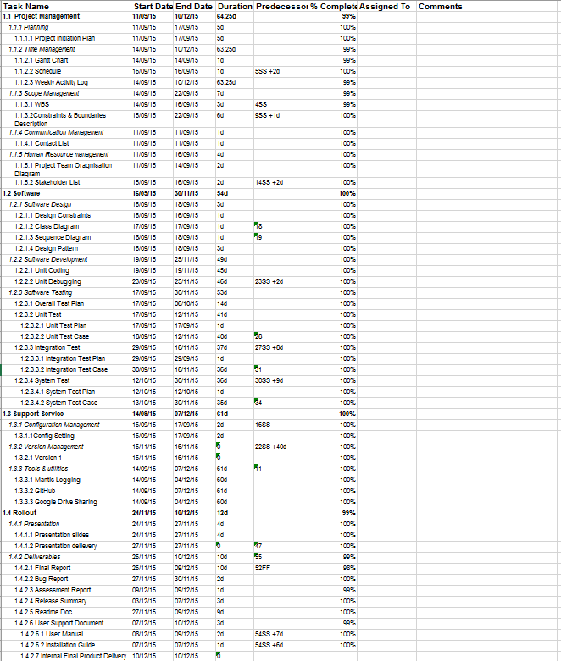

2.6 GANTT CHART

Gantt chart is produced during project planning at the early stage. To develop a good gantt chart for better project management, the WBS is taken into accounts and start time and end time of individual project tasks is , therefore, arranged. It can generate an overview of the project estimated schedule for us to refer to.

Unlike schedule, Gantt chart is more flexible and should be updated regularly. This is because it contains details like “% completed”, “duration” “Assigned to”. Due to the dynamic nature of the project, duration of tasks may vary and task responsibility may shift in the project cycle. Therefore, project managers had kept the Gantt chart up-to-date to ensure the project follow good progress as well as to enhance project management. Besides, milestones are added to represent significant events in project cycle. These include our program 1st release and presentation delivery. Milestones act as important indicators for project status and help project managers to monitor project progress. According to the current status, two of our main milestones are met, thus, it is foreseen that we have high chance to complete the final project before delivery deadline.

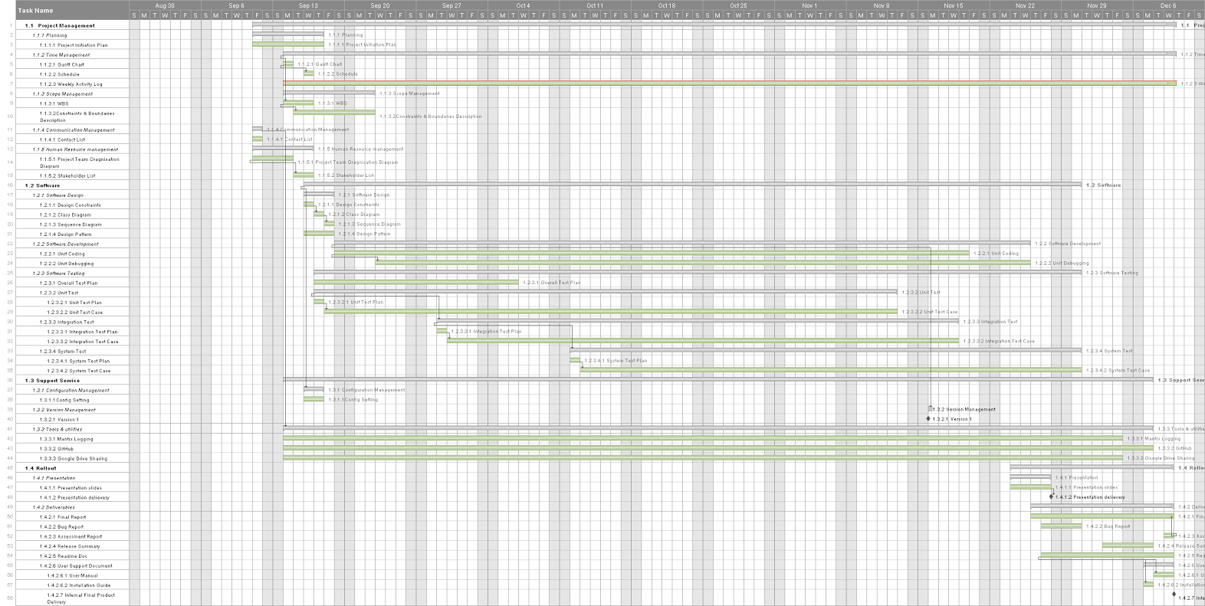

2.7 CRITICAL PATH ANALYSIS

Red highlighted task is the critical path, which is weekly activity log. It is the critical path because it takes the longest period of time to complete throughout the project. It represents the importance and significance of keeping a good weekly activity log updates regularly.

In light of documenting project performance, it is essential for the activity logs with every completed subdividied tasks to be updated on a weekly basis. This help to determine project status at the current state as well as monitoring the project progress over a period of time. Moreover, weekly activity log enable management plan to be planned and executed. Based on identified activity completed, managers can predict the future scope and time management plan to achieve milestones and meet project deadline.

Representing a critical path alone, the process of completing weekly activity logs should be well planned and followed to avoid any delays. Once there is a delay in logging the weekly completed activity, a delay in project will likely happen. Therefore, weekly updating activity logs are adopted to prevent delay of critical path.

2.8 Schedule

Tasks | Start date | End Date
1. Project Management
1.1 Planning | 11 SEP 2015 | 17 SEP 2015
1.2 Time Management | 14 SEP 2015 | 10 DEC 2015
1.3 Scope Management | 14 SEP 2015 | 22 SEP 2015
1.4 Communication Management | 11 SEP 2015 | 11 SEP 2015
1.5 Human Resources Management | 11 SEP 2015 | 16 SEP 2015
2. Software
2.1 Software Design | 16 SEP 2015 | 18 SEP 2015
2.2 Software Development | 19 SEP 2015 | 25 NOV 2015
2.3 Software Testing | 17 SEP 2015 | 30 NOV 2015
3. Support Services
3.1 Configuration Management | 16 SEP 2015 | 17 SEP 2015
3.2 Tools and Utilities | 14 SEP 2015 | 7 DEC 2015
4. Rollout
4.1 Presentation | 23 NOV 2015 | 9 DEC 2015
4.2 Deliverables | 26 NOV 2015 | 9 DEC 2015

2.9 SOFTWARE DEVELOPMENT METHODOLOGY

The Software development methodology used is Test-driven Development.

In the cycle, we firstly write the program code and add new test cases to the program. The test cases will be run to see if any one of them fails. If no, then the code will be refactored.

After that, we will start a new cycle, aims at adding new functions and improving the previous functions. And the above steps are repeated.

2.10 SOFTWARE CONFIGURATION

Operating environment: Windows (7, 8, XP, 10), Mac OS, Linux, with JRE
Programming specification: JDK
Development Environment: Eclipse 4.3 / Eclipse

2.11 USE OF TECHNOLOGIES AND PLATFORMS

Throughout the entire project cycle, multiple technologies and platforms are used to enhance project communication and project development:

- Bug Tracking: Mantis

Mantis Hub is an online platform especially for report logging in project. It is used to aid our bug detection and bug reporting process. Upon program bugs are detected at the early stage by the testing engineer, relevant Mantis log will be issued and assigned to related developing analyst. After, logs will be analyzed and investigated with a view to resolve existing bugs/ technical problems. Mantis Hub plays an important in the project as bug reporting platform. It aids our project debugging and program development.

- Development Communication: GitHub

GitHub acts as a platform for program sharing and debugging. Updates of the programs are committed and pull requests are carried out to keep the entire program up to date.

(c) Development: JAVA, Eclipse

Java programming is used to develop this program while Eclipse is used as tool for writing java programs. Due to its capability to organize codes into classes and packages, entire program can be splint among developing team, and hence, project development becomes more organised and effortless.

(d) Testing framework: JUnit

JUnit is testing framework to support java programming language. Because of the fact that project adopted the test-driven methodology in development, it is important to have a well-built unit testing framework like JUnit to aid program testing.

3. ANALYSIS

3.1 DESIGN CONSTRAITS

Input format

Design constraints mainly revolves around easy use of product. For this, we try to let the user do as little things as possible by letting them copy and paste the whole master class schedule entry, with minimal edit works. We introduce a simple text file format for inputs featuring lines of Meeting records separated by blank lines, with the first line being the course code. This enables the user to prepare the text file with simple tools such as notepad or spreadsheet.
Below is the suggested input format. The each block contains the course code in the first line, followed by lines of Meeting entries that can be directly copied from the master class schedule, then there will be a blank line. For each Meeting entry, there will be tab-separated values stating the CRN, date, time and other details about the class. Note the second column (“C01”, “T02” etc.) specifies the type of meeting (Lecture or Tutorial)
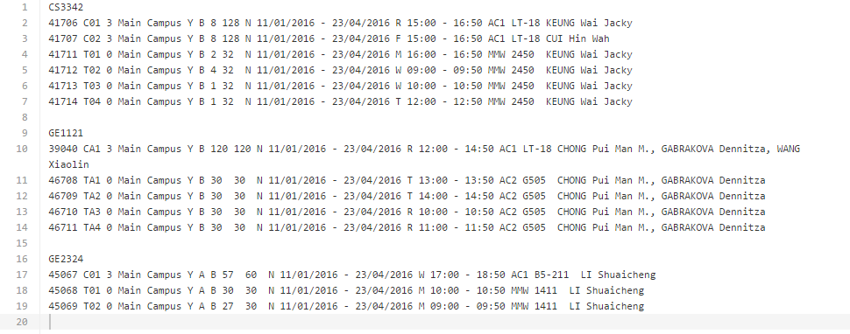

For simplicity we only include Lecture and Tutorials and omitted other Meeting types such as Labs. They can be added in future releases.

Comparing rules

There are lots of ways to compare timetables. These include counting late night classes or counting empty hours. We have to fibd way to structure our program so that new rules are easily added and maintained. Users can choose to maximize some variables and minimize the others, and the program should compare available timetables according to such a flexible set of rules.

3.2 CLASS DIAGRAM

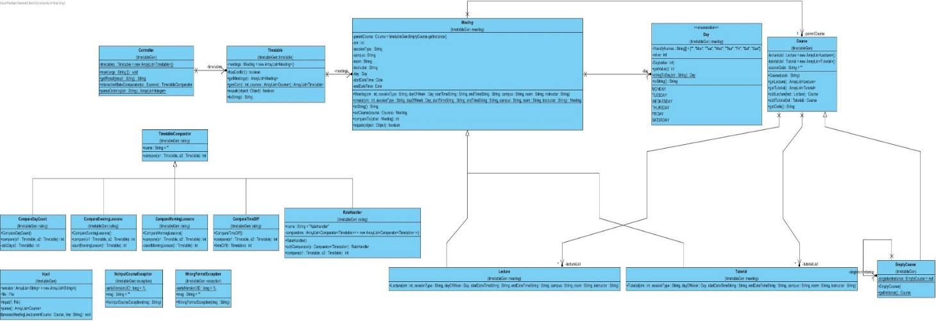
As the diagram may be too large and may not be shown clearly. In a more detail look:
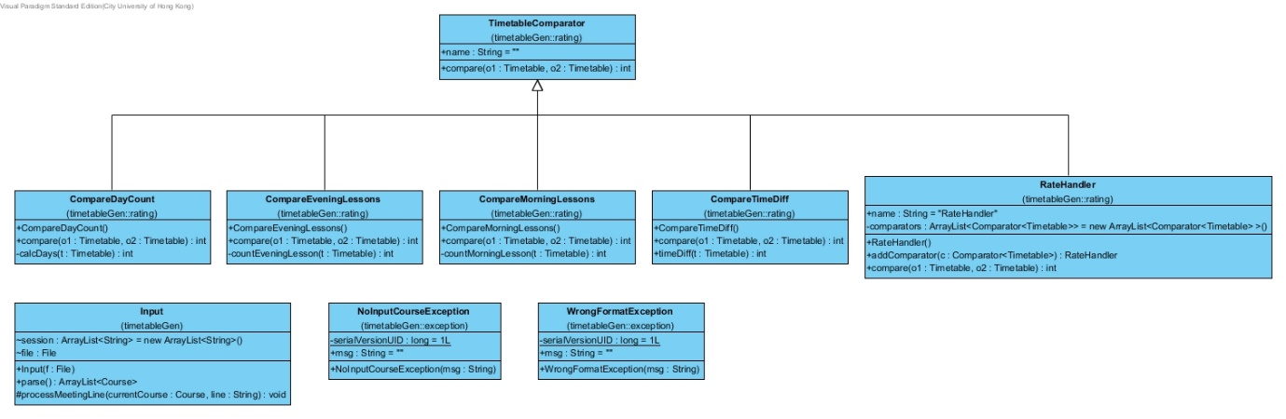
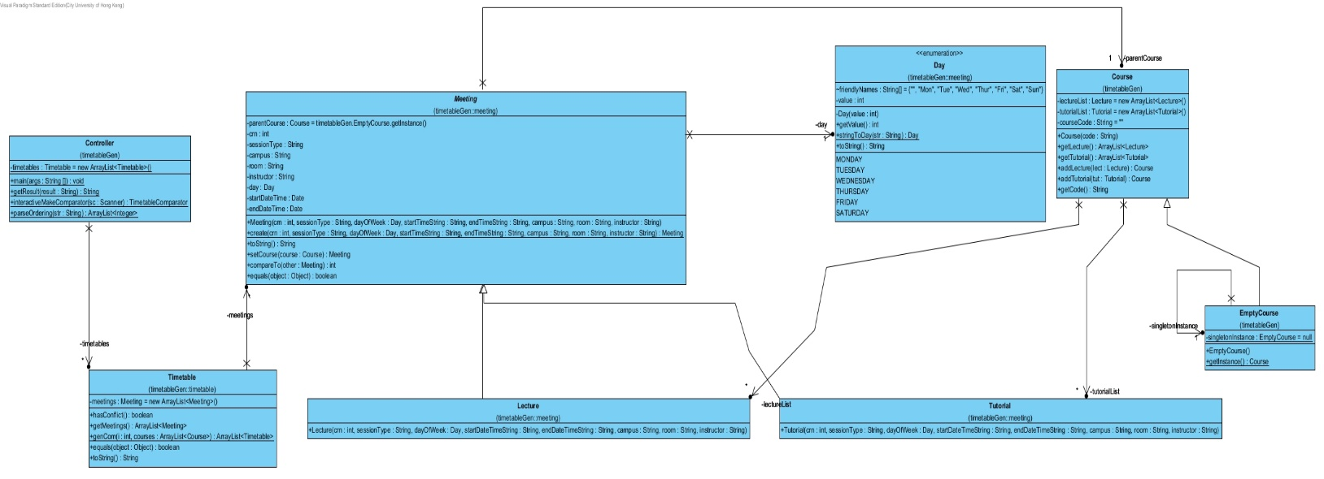

3.3 SEQUENCE DIAGRAM

For the main():
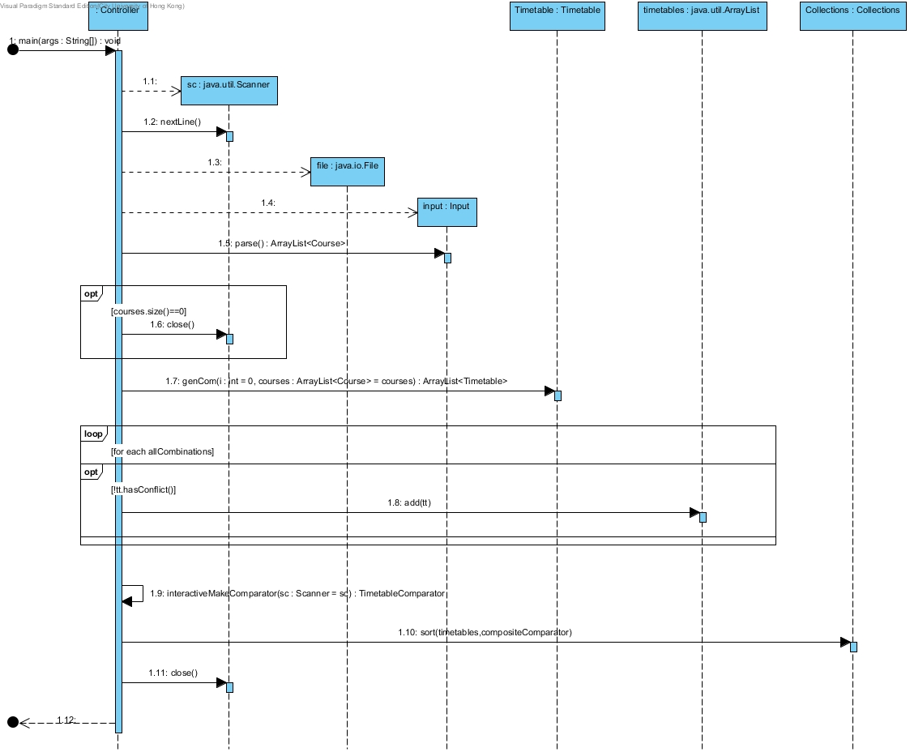

For the generation of all combination of timetable:
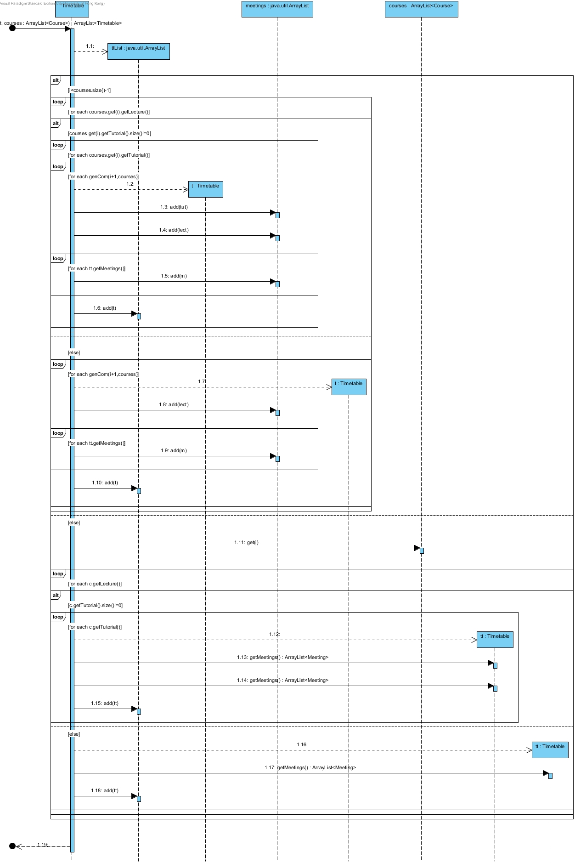

3.4 DESIGN PATTERN

Factory pattern
Factory pattern is used when creating a Meeting. In Input, we can see that Lectures and Tutorials share very similar format, and we create the instances at the same time as paring them. We utilize the abstract class Meeting and add a Meeting.create() that infers the meeting type by itself and return two different objects that are both Meetings.
Meeting
Lecture
Tutorial

creates

Composite pattern
Composite pattern is used to customize sorting functions. We let users choose their priority for sorting Timetables and provide different sorting strategies for them to prioritize their timetables. RateHandler is composed interactively with the user, who gives an ordered list of comparators. RateHandler then executes the given Comparators one by one until it can find a better timetable than the other. The whole RateHandler is then applies to the sort() function, which sorts the possible timetables and find the top 3 that matches the user’s expectations.
Comparator
<Timetable>
<Interface>
TimetableComparator
__________

+name
<Abstract>
CompareDayCount

CompareMorningLesson
CompareEveningLesson
CompareTimeDiff

RateHandler
___________

+comparators

0...M
Outsiders use this to compare with 1 or more Comparators

4. TEST PLAN

4.1 TESTING MODULE HIERARCHY
main
parse
course
timetable
meeting
Day
CompareTimeDiff
lecture
tutorial
CompareMorningLessons
hasConflict
RateHandler
CompareEveningLessons
genCombination
processMeetingLine
Exception
CompareDayCount

4.2 TEST DESCRIPTION: Bottom-up Approach

In this project, we are using bottom-up Approach for our testing plan. Bottom-up Approach can help solve the problem from the bottom-root first. Thus. it makes the conditions of the program becomes more easier to plan and control. There is no need to create any test stub by using bottom-up approach. We can have high deployment coverage in early phases. Therefore, earlier return on be given to our project. The ability of test will also easier. Also, there is high visibility of organizational changes and high impact to organization.

When comparing to other approach such as top-down approach, we can have higher ability of parallelism in the beginning of the project. In other words, using bottom up approach is more efficient for us to finish the project. The top-down approach will provides limited coverage at the beginning stage. A minimal percentage of user accounts are managed at the beginning. If we adopt top-down approach, we might have to develop custom adapters at an early stage. The implementation cost is likely to be higher. As a result, we finally decide to use bottom-up approach in our testing plan.

4.3 UNIT TEST
main
parse
course
timetable
meeting
Day
CompareTimeDiff
lecture
tutorial
CompareMorningLessons
hasConflict
RateHandler
CompareEveningLessons
genCombination
processMeetingLine
Exception
CompareDayCount
At the beginning of the testing, we test the bottomost parts of the system.

- genCombination
Purpose: Check whether the program can generate all possible case of the timetable combinations.

- hasConflict
Purpose: Check whether there is a time crash between different lectures and tutorials.

- CompareEveningLessons
Purpose: Check whether the counting of the number of lesson at night is correct.

- CompareMorningLessons
Purpose: Check whether the counting of the number of lesson in the morning is correct.

- CompareDayCount
Purpose: Check whether the counting of the number of school days is correct.

- CompareTimeDiff
Purpose: Check whether the counting of the number of hours to be spent on the same day is correct.

- Exception
Purpose: Check whether the handling of wrong input and format suit as our expectation.

4.4 INTEGRATION TEST

After performing the unit testing, we undergo 3 integration test.

main
parse
course
timetable
meeting
Day
CompareTimeDiff
lecture
tutorial
CompareMorningLessons
hasConflict
RateHandler
CompareEveningLessons
genCombination
processMeetingLine
Exception
CompareDayCount
figure 1(a) Integration Test 1 & 2

Noted : *() = used as data structure only

- Refer to figure 1(a), Integration test 1: CompareMorningLessons + CompareEveningLessons + CompareDayCount +CompareTimeDiff + RateHandler (+meeting)

Purpose: Check whether the Rate method can interact theCompareMorningLessons, CompareEveningLessons, CompareDayCount, CompareTimeDiff successfully and generate the correct rating score.

- Refer to figure 1(a), Integration test 2: hasConflict + genCombination + timetable (+meeting, lecture, tutorial)

Purpose: Check whether the timetable method can call the hasConflict and genCombination method successfully and produce the feasible timetable combination.
main
parse
course
timetable
meeting
Day
CompareTimeDiff
lecture
tutorial
CompareMorningLessons
hasConflict
RateHandler
CompareEveningLessons
genCombination
processMeetingLine
Exception
CompareDayCount
Figure 1(b) Integration test 3

- Refer to figure 1(b), Integration test 3: CompareMorningLessons + CompareEveningLessons + CompareDayCount +CompareTimeDiff + RateHandler +hasCnflict +genCombination+ timetable + meeting+stringToDay+processMeetingLine+ tutorial+lecture
Purpose: Check whether the interaction between these method is correct and are able to produce the expected the result.

4.5 SYSTEM TEST

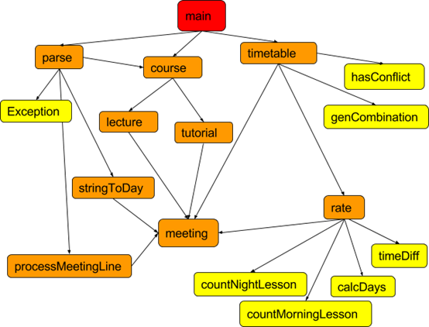
After testing the unit test and integration test, we perform the system test. The system test are conducted on a complete, integrated system to evaluate the stability and functionality fit with our expectation.

Our testing plan has covered all methods and branches. The Main will be tested manually, but we indeed achieve the statement coverage and branch coverage.
Here we are using blackbox testing, which we only focus on the inputs and what the expected outcomes of the program rather than how the program arrives at those outputs for the testing.

The advantages of blackbox testing:

- The test is unbiased because the designer and the tester are independent of each other.
- The tester does not need knowledge of any specific programming languages.
- The test is done from the point of view of the user, not the designer.
- Test cases can be designed as soon as the specifications are complete.

We assume the users will input the test file with the course they want to take in the future semester. The output timetable must have no time crash, and contain one lecture with one corresponding tutorial. It will be rated according to the users’ preference.

Below is the input file that are likely to be:

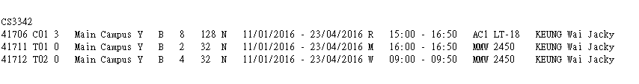

The sample test case will be:

- Input file contains courses with time crash
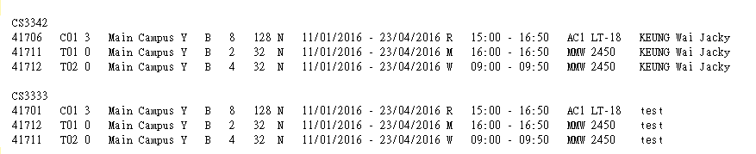

Expected Result: There should be no timetable can be generated.

- Input file contains only one possible timetable can be generated
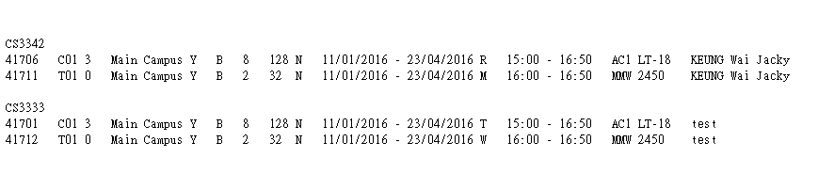
Expected Result: There will be one timetable to be generated without any time crash.

- User’s rating preference as Fewest days> Fewest Morning Lessons > Fewest Evening Lessions > Shortest days

Thus, the test plan of this case will be:

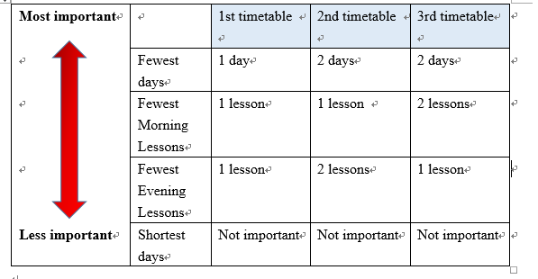
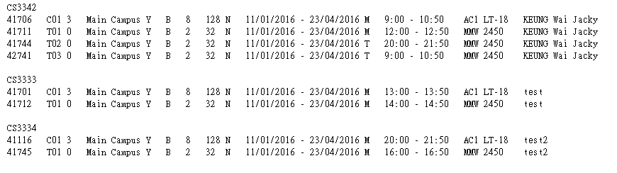
This is the sample input file for this case:

Expected Output:
- The best sequencing of output for the user will be 41706, 41711, 41701, 41712, 41116, 41745.
- The second-best sequencing will be 41706, 41744 41701, 41712, 41116, 41745.
- The third-best Best sequencing will be 41706, 42741 41701, 41712, 41116, 41745.

- Input with invalid format
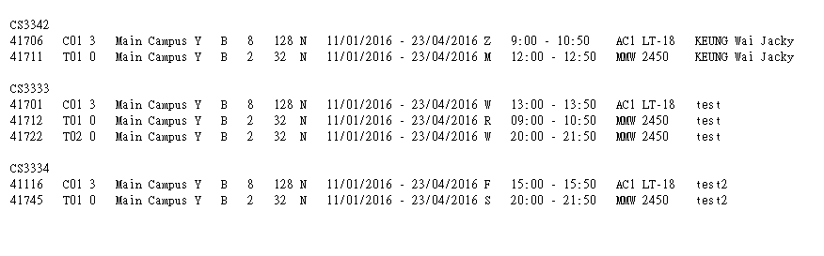
In the line 1 of the input test file, there is a “Z” in the 11th column which represent the day of the week. “Z" character does not represent any of the day of the week. Therefore, the program will consider this is wrong input format.

Expected Output:
The program will be terminated once encounters the wrong input format. No timetable output is generated.

Bug Report 1

Github Issue Number | #13
Title | enum Day.stingToDay(String str) cannot detect wrong input string that start with MTWRFS
Date | 13-11-2015 12:52
Originator | Maya
Owner | Dickson
Found in | Input Parser
Severity | Major - blocking
Summary | In Meeting details, user can mistakenly produce a wrong Day code such as Ma
Steps to reproduce | input case:  41714 T04 0 Main Campus Y B 1 32 N 11/01/2016 - 23/04/2016 Ta 12:00 - 12:50 MMW 2450 KEUNG Wai Jacky  as one of the lines. note that the Day code is Ta instead of T
Expected | throw new WrongFormatException("Day should be one of MTWRFS");
Actual | Only first character is processed
Status | Fixed

Bug Report 2

Github Issue Number | #14
Title | Output string cannot be understood by normal human beings
Date | 12-11-2015 13:21
Originator | Maya
Owner | Dickson
Found in | Output
Severity | Minor - non blocking
Summary | Poor implementation of Meeting.toString() cause output format non-understandable, as follow:  CRN: 45069 Sesion: T02 Time: Mon Sep 01 09:00:00 CST 2014 - Mon Sep 01 09:50:00 CST 2014 Campus: MMW Room: 1411 Instructor: LI Shuaicheng  Is too clumped up and course code is not seen
Steps to reproduce | CS3342  41706 C01 3 Main Campus Y B 8 128 N 11/01/2016 - 23/04/2016 R 15:00 - 16:50 AC1 LT-18 KEUNG Wai Jacky  41707 C02 3 Main Campus Y B 8 128 N 11/01/2016 - 23/04/2016 F 15:00 - 16:50 AC1 LT-18 CUI Hin Wah  41711 T01 0 Main Campus Y B 2 32 N 11/01/2016 - 23/04/2016 M 16:00 - 16:50 MMW 2450 KEUNG Wai Jacky  41712 T02 0 Main Campus Y B 4 32 N 11/01/2016 - 23/04/2016 W 09:00 - 09:50 MMW 2450 KEUNG Wai Jacky  41713 T03 0 Main Campus Y B 1 32 N 11/01/2016 - 23/04/2016 W 10:00 - 10:50 MMW 2450 KEUNG Wai Jacky  41714 T04 0 Main Campus Y B 1 32 N 11/01/2016 - 23/04/2016 T 12:00 - 12:50 MMW 2450 KEUNG Wai Jacky  GE1121  39040 CA1 3 Main Campus Y B 120 120 N 11/01/2016 - 23/04/2016 R 12:00 - 14:50 AC1 LT-18 CHONG Pui Man M., GABRAKOVA Dennitza, WANG Xiaolin  46708 TA1 0 Main Campus Y B 30 30 N 11/01/2016 - 23/04/2016 T 13:00 - 13:50 AC2 G505 CHONG Pui Man M., GABRAKOVA Dennitza  46709 TA2 0 Main Campus Y B 30 30 N 11/01/2016 - 23/04/2016 T 14:00 - 14:50 AC2 G505 CHONG Pui Man M., GABRAKOVA Dennitza  46710 TA3 0 Main Campus Y B 30 30 N 11/01/2016 - 23/04/2016 R 10:00 - 10:50 AC2 G505 CHONG Pui Man M., GABRAKOVA Dennitza  46711 TA4 0 Main Campus Y B 30 30 N 11/01/2016 - 23/04/2016 R 11:00 - 11:50 AC2 G505 CHONG Pui Man M., GABRAKOVA Dennitza  GE2324  45067 C01 3 Main Campus Y A B 57 60 N 11/01/2016 - 23/04/2016 W 17:00 - 18:50 AC1 B5-211 LI Shuaicheng  45068 T01 0 Main Campus Y A B 30 30 N 11/01/2016 - 23/04/2016 M 10:00 - 10:50 MMW 1411 LI Shuaicheng  45069 T02 0 Main Campus Y A B 27 30 N 11/01/2016 - 23/04/2016 M 09:00 - 09:50 MMW 1411 LI Shuaichen
Expected | line formatting should be  CRN: 45069 | Course: [CourseCode] | Section: T02 | Day: Mon | Time: 09:00-09:50 | Campus: MMW | Room: 1411 | Instructor: LI Shuaicheng
Actual | CRN: 45069 Sesion: T02 Time: Mon Sep 01 09:00:00 CST 2014 - Mon Sep 01 09:50:00 CST 2014 Campus: MMW Room: 1411 Instructor: LI Shuaicheng
Status | Fixed

Bug Report 3

Github Issue Number | #18
Title | Crash when no possible timetable is produced
Date | 11-12-2015 20:51
Originator | Maya
Owner | Dickson
Found in | Output / RateHandler
Severity | Major - blocking
Summary | Program cannot deal with input that crash anyways. When no timetable is produced, the program still attempts to print the results out of an empty array.
Steps to reproduce | input case:  CS3342  41706 C01 3 Main Campus Y B 8 128 N 11/01/2016 - 23/04/2016 R 15:00 - 16:50 AC1 LT-18 KEUNG Wai Jacky  41711 T01 0 Main Campus Y B 2 32 N 11/01/2016 - 23/04/2016 M 16:00 - 16:50 MMW 2450 KEUNG Wai Jacky  41712 T02 0 Main Campus Y B 4 32 N 11/01/2016 - 23/04/2016 W 09:00 - 09:50 MMW 2450 KEUNG Wai Jacky  CS3333  41701 C01 3 Main Campus Y B 8 128 N 11/01/2016 - 23/04/2016 R 15:00 - 16:50 AC1 LT-18 test  41712 T01 0 Main Campus Y B 2 32 N 11/01/2016 - 23/04/2016 M 16:00 - 16:50 MMW 2450 test  41711 T02 0 Main Campus Y B 4 32 N 11/01/2016 - 23/04/2016 W 09:00 - 09:50 MMW 2450 test  Sorting preference: 1 2 3 4 (any is ok)
Expected | No timetable should be generated since it is impossible
Actual | Exception in thread "main" java.lang.IndexOutOfBoundsException: Index: 0, Size: 0  at java.util.ArrayList.rangeCheck(ArrayList.java:635)  at java.util.ArrayList.get(ArrayList.java:411)  at timetableGen.Controller.main(Controller.java:59)
Status | Fixed

Bug Report 4

Github Issue Number | #19
Title | Crash when less than 3 possible timetable are produced
Date | 11-12-2015 20:53
Originator | Maya
Owner | Dickson
Found in | Output / RateHandler
Severity | Major - has workaround
Summary | Same bugs occurs when only one (< 3) timetables available (no time crash)
Steps to reproduce | input case:  CS3342  41706 C01 3 Main Campus Y B 8 128 N 11/01/2016 - 23/04/2016 R 15:00 - 16:50 AC1 LT-18 KEUNG Wai Jacky  41711 T01 0 Main Campus Y B 2 32 N 11/01/2016 - 23/04/2016 M 16:00 - 16:50 MMW 2450 KEUNG Wai Jacky  CS3333  41701 C01 3 Main Campus Y B 8 128 N 11/01/2016 - 23/04/2016 T 15:00 - 16:50 AC1 LT-18 test  41712 T01 0 Main Campus Y B 2 32 N 11/01/2016 - 23/04/2016 W 16:00 - 16:50 MMW 2450 test  Sorting preference: 1 2 3 4 (any is ok)
Expected | Generate one timetables, no time crash
Actual | One timetable, followed by this message:  Exception in thread "main" java.lang.IndexOutOfBoundsException: Index: 1, Size: 1  at java.util.ArrayList.rangeCheck(ArrayList.java:635)  at java.util.ArrayList.get(ArrayList.java:411)  at timetableGen.Controller.main(Controller.java:59)
Status | Fixed

Bug Report 5

Github Issue Number | #20
Title | Incorrect output with preference input
Originator | Maya
Owner | Dickson
Date | 20-11-2015 21:03
Found in | RateHandler
Severity | Major - no workarounds
Summary | the constructor of the RateHandler class has one extra comparator to start with
Steps to reproduce | input case:  CS3342  41706 C01 3 Main Campus Y B 8 128 N 11/01/2016 - 23/04/2016 R 15:00 - 16:50 AC1 LT-18 KEUNG Wai Jacky  41707 C02 3 Main Campus Y B 8 128 N 11/01/2016 - 23/04/2016 F 15:00 - 16:50 AC1 LT-18 CUI Hin Wah  41711 T01 0 Main Campus Y B 2 32 N 11/01/2016 - 23/04/2016 M 16:00 - 16:50 MMW 2450 KEUNG Wai Jacky  41712 T02 0 Main Campus Y B 4 32 N 11/01/2016 - 23/04/2016 W 09:00 - 09:50 MMW 2450 KEUNG Wai Jacky  41713 T03 0 Main Campus Y B 1 32 N 11/01/2016 - 23/04/2016 W 10:00 - 10:50 MMW 2450 KEUNG Wai Jacky  41714 T04 0 Main Campus Y B 1 32 N 11/01/2016 - 23/04/2016 T 12:00 - 12:50 MMW 2450 KEUNG Wai Jacky  GE1121  39040 CA1 3 Main Campus Y B 120 120 N 11/01/2016 - 23/04/2016 R 12:00 - 14:50 AC1 LT-18 CHONG Pui Man M., GABRAKOVA Dennitza, WANG Xiaolin  46708 TA1 0 Main Campus Y B 30 30 N 11/01/2016 - 23/04/2016 T 13:00 - 13:50 AC2 G505 CHONG Pui Man M., GABRAKOVA Dennitza  46709 TA2 0 Main Campus Y B 30 30 N 11/01/2016 - 23/04/2016 T 14:00 - 14:50 AC2 G505 CHONG Pui Man M., GABRAKOVA Dennitza  46710 TA3 0 Main Campus Y B 30 30 N 11/01/2016 - 23/04/2016 R 10:00 - 10:50 AC2 G505 CHONG Pui Man M., GABRAKOVA Dennitza  46711 TA4 0 Main Campus Y B 30 30 N 11/01/2016 - 23/04/2016 R 11:00 - 11:50 AC2 G505 CHONG Pui Man M., GABRAKOVA Dennitza  GE2324  45067 C01 3 Main Campus Y A B 57 60 N 11/01/2016 - 23/04/2016 W 17:00 - 18:50 AC1 B5-211 LI Shuaicheng  45068 T01 0 Main Campus Y A B 30 30 N 11/01/2016 - 23/04/2016 M 10:00 - 10:50 MMW 1411 LI Shuaicheng  45069 T02 0 Main Campus Y A B 27 30 N 11/01/2016 - 23/04/2016 M 09:00 - 09:50 MMW 1411 LI Shuaichen  Sorting preference: 4 2 3 1 (not starting with 1)
Expected | Timetables with lowest timeDiff comes first
Actual | Timetables with lowest dayCount comes first
Status | Fixed

